MINISTRY OF EDUCATION AND TRAINING

FPT UNIVERSITY
Capstone Project Document
[Software Defect Registration and Resolution Tracking in SAP (SU26SAP12)]

GSU26SAP12
Group Members | Nguyễn Tiến Dũng - SE184951  Bùi Quang Tuấn - SE184982  Phạm Thị Minh Ánh - SE181595
Supervisor | Nguyễn Hoàng Linh
Ext Supervisor | Lê Nguyễn Sơn Vũ

- Ho Chi Minh, August 2026 -

Table of Contents

Acknowledgement 4
Definition and Acronyms 4
I. Project Introduction 5
1. Overview 5
2. Product Background 5
3. Existing Solutions 5
4. Business Opportunity 5
5. Software Product Vision 5
6. Project Scope & Limitations 5
II. Project Management Plan 6
1. Overview 6
2. Management Approach 6
3. Project Deliverables 6
4. Responsibility Assignments 6
5. Project Communications 6
6. Configuration Management 6
III. Software Requirement Specification 7
1. Requirement Overview 7
2. Functional Specifications 7
3. UI Requirements 7
4. Non-Functional Requirements 8
5. Requirement Appendix 8
IV. Software Design Description 8
1. System Design 8
2. Database Design 8
3. Detailed Design 9
V. Software Testing Documentation 10
1. Scope of Testing 10
2. Test Strategy 10
3. Test Plan 10
4. Test Cases 10
5. Test Reports 10
VI. Release Package & User Guides 11
1. Deliverable Package 11
2. Installation Guides 11
3. User Manual 11

Acknowledgement
We would like to express our sincere gratitude to FPT University, our lecturers, mentors, and project supervisors for their guidance and support throughout the development of this project.
We also would like to thank the SAP training environment and technical resources that enabled us to study and implement the SAP Defect Management System using SAPUI5, OData V4, ABAP RAP, CDS View Entities, and SAP HANA custom tables.
This project helped our team gain practical experience in analyzing business requirements, designing data models, developing SAP Fiori applications, implementing backend business logic, preparing technical documentation, and performing software testing.
Finally, we would like to thank all team members for their contribution, collaboration, and effort during the project implementation and documentation process.

Definition and Acronyms
Acronym | Definition
SAP | Systems, Applications and Products in Data Processing
SAPUI5 | SAP User Interface Development Toolkit for HTML5
Fiori | SAP design system and user experience standard
RAP | RESTful ABAP Programming Model
ABAP | Advanced Business Application Programming
CDS | Core Data Services
OData | Open Data Protocol
OData V4 | Open Data Protocol Version 4
API | Application Programming Interface
UI | User Interface
GUI | Graphical User Interface
MVC | Model View Controller
JSON | JavaScript Object Notation

I. Project Introduction
The SAP Defect Management System project was built to standardize the process of recording, assigning, handling, and tracking errors occurring in SAP modules such as FI, MM, SD, HCM, PP, and QM. The application uses SAPUI5 1.120+ at the frontend and connects to the ABAP RAP backend via OData V4. The system supports ticket creation, automatic or manual developer assignment, error handling lifecycle management, audit history storage, comments, attachments, worklists by role, and KPI dashboards for management.

1. Overview

1.1 Project Information
Project name: SAP Defect Management System
Project code / Function ID: BTTICKET
Technology stack: SAPUI5 1.120+, TypeScript, ABAP RAP, CDS View Entities, OData V4, SAP HANA custom Z tables.
Document generated date: 08/06/2026
Item | Content
Project name | SAP Defect Management System
Project code / Function ID | BTTICKET
Application ID | sap.defectmgmt
Domain | SAP ERP – Cross Application / Quality & Defect Tracking
Project type | Capstone / Graduation project – Full-stack SAP application
Frontend | SAPUI5 1.120+, TypeScript, XML Views, MVC
Backend | ABAP OO, RAP Framework, CDS View Entities, OData V4
Database | SAP HANA – Custom transparent Z tables
Service URL | /sap/opu/odata4/sap/zui_issue_srvbind/srvd/sap/zui_issue_srvdef/0001/
SAP modules covered | FI, MM, SD, HCM, PP, QM
Main roles | TESTER, DEVELOPER, MANAGER
Document date | 08/06/2026

Brief description:
SAP Defect Management System is a Fiori-based application used to create, assign, process, verify, and close defect tickets related to SAP functional modules. The system standardizes the defect lifecycle from creation to closure, with audit history, role-based worklists, and management KPI dashboard.

1.2 Project Team

No. | Role | Responsibility
1 | Backend Developer(Nguyễn Tiến Dũng) | ABAP RAP, CDS, Dictionary objects, business logic (ZCL_BTTICKET_MANAGER), OData service
2 | Frontend Developer (Bùi Quang Tuấn) | SAPUI5/TypeScript screens, controllers, OData binding, role-based UI
3 | Frontend Developer( Phạm Thị Minh Ánh ) | Issue Detail, Dashboard, Worklists, formatter, validation, UX polish
4 | Business Analyst / Documentation(  Nguyễn Tiến Dũng, Bùi Quang Tuấn, Phạm Thị Minh Ánh) | Requirements, deliverables, test scenarios, final report

2. Product Background

During the deployment and operation of SAP modules (FI, MM, SD, HCM, PP, QM), business and technical errors constantly arise during the testing, hypercare, and operation phases. Without a centralized management tool, errors are often tracked using Excel, email, or chat—leading to:

Lack of standardized procedures for ticket status; Difficulty assigning developers by module and workload; Lack of clear audit trails; Difficulty for managers to track KPIs (open, overdue, critical, reopen rate); Lack of separate worklists for testers and developers based on their roles.

The SAP Defect Management System was created to address these issues with a unified SAP Fiori application: Testers create tickets, developers process and resolve them, and managers monitor and reassign them. The system uses SAPUI5 on the frontend and ABAP RAP + OData V4 on the backend, conforming to the standard SAP S/4HANA architecture.

3. Existing Solutions
Solution | Description | Limitation for this project
Excel / Google Sheet tracking | Manual bug tracking | No automated workflow, authorization, or audit
Email / Chat | Discussing bugs via Zalo, Messenger | No standard lifecycle, KPI, or history
Jira / Azure DevOps | Popular issue tracking tool | Not deeply integrated into SAP module, developer master, RAP authorization
SAP Solution Manager / Focused Build | SAP's defect management tool | Complex, heavy, not suitable for project scope
Custom Z-report (SE38) | Classic ABAP report | Poor UI, no Fiori, difficult for role-based UX

Business Opportunity

Business Problem
- A standardized defect management process is needed for the SAP functional/technical team.
- Developers need to be assigned by module and workload.
- SLAs, reopens, and critical tickets need to be monitored.
- All status changes need to be audited.

Opportunities
- Standardize the process: ASSIGNED → IN_PROGRESS → RESOLVED → TESTING → CLOSED (+ REOPEN)
- Reduce search, reassignment, and reporting time.
- Increase transparency between Tester – Developer – Manager.
- Create a foundation for future expansion (notifications, SLA escalation, AI suggestions – out of the current scope).

Value delivered

Stakeholder | Value
Tester | Tạo ticket nhanh, worklist verify, close/reopen rõ ràng
Developer | My Work theo ticket được gán, resolve có root cause/fix description
Manager | Dashboard KPI, reassign, theo dõi workload

5. Software Product Vision

Vision statement:
“To provide a standardized, role-based SAP Fiori Defect Management System that enables testers, developers, and managers to create, process, verify, and monitor SAP defects end-to-end with full auditability and transparent KPIs.”
Product intent
- A single Fiori application for the entire defect lifecycle
- Connects to actual SAP modules (FI/MM/SD/HCM/PP/QM)
- Workflow based on RAP-bound actions, not just manual patching
- Clear role matrix: TESTER / DEVELOPER / MANAGER
World after the product
- No more tracking fragmented defects in files
- Each ticket has status, assignee, due date, version, and history
- Managers can see open/overdue/critical/reopen on the dashboard
- Teams work according to standard SAP-oriented processes

6. Project Scope & Limitations
6.1 In Scope (Must have)
Area | Included
Frontend | Login (demo), IssueList, CreateIssue, IssueDetail, Dashboard, DeveloperWorklist, TesterWorklist
Backend | 5 Z tables, CDS views, RAP behavior, OData V4 service, 6 lifecycle actions
Business | Create + assign, start progress, resolve, start testing, close, reopen, reassign
Data | Comments, attachments (metadata), audit history, developer workload
Auth concept | Role-based UI + AUTHORITY-CHECK object Z_BTTICKET_ACT
Docs/Test | Functional/Technical Spec, Configuration Note, Unit/Functional/Scenario/UAT, Blueprint, Final Report

6.2 Out of Scope
Item | Reason
Email-to-Ticket | Beyond the scope of the project
AI suggestion (severity/root cause/duplicate) | Optional, not yet implemented.
REST API for Jira/Selenium | Not part of the main Fiori style.
Background SLA escalation job | Not yet implemented
Status NEW | Create a ticket and assign it immediately → status ASSIGNED

6.3 Known Limitations (current)
- Login demo — hardcoded tester/dev/manager + password 123; production needs SAP auth/SSO
- Dashboard client-side — load maximum ~1000 Issue + ~2000 History then aggregate on browser
- Attachment — mainly stores metadata (file_name, mime_type, file_size), but not full binary flow
- flexEnabled: false — UI Flexibility/personalization is not enabled
- Frontend automated tests — no full QUnit/OPA5 yet
- SADL write constraint — some create paths need to degrade gracefully when the backend restricts writing
6.4 Future improvements

- Real SAP authentication
- Server-side KPI aggregation
- Full attachment upload/download
- Enable Flex personalization
- Frontend automated tests + CI
- Notification/SLA escalation (later stage)

II. Project Management Plan

1. Overview

1.1 Scope & Estimation
The project covers the end-to-end implementation of the SAP Defect Management System, including frontend SAPUI5 development, backend ABAP RAP development, documentation, and testing.
Software product breakdown
No. | Work Package | Category | Description | Estimation
1 | Requirement Analysis | Business Analysis | Collect and refine defect lifecycle requirements, roles, and business rules | 1 week
2 | Data Dictionary Design | Backend | Design and implement Z tables, domains, and data elements | 1 week
3 | CDS & OData Service | Backend | Build CDS view entities, service definition, and service binding | 1 week
4 | Business Logic & RAP Actions | Backend | Implement ZCL_BTTICKET_MANAGER, behavior definition, and 6 lifecycle actions | 1–2 weeks
5 | Fiori Screens – Core | Frontend | Develop Login, IssueList, CreateIssue, and IssueDetail | 2 weeks
6 | Worklists & Dashboard | Frontend | Develop DeveloperWorklist, TesterWorklist, and Manager Dashboard | 1 week
7 | Role-based UI & Integration | Frontend/Backend | Connect OData V4, role visibility, validations, and action handling | 1 week
8 | Unit & Functional Testing | Testing | Prepare and execute unit, functional, and integration test cases | 1 week
9 | Documentation & Demo | Documentation | Prepare Functional Spec, Technical Spec, Configuration Note, Blueprint, Final Report, and demo | 1 week

Total estimated duration: approximately 8 weeks

Project scope summary
In Scope | Out of Scope
Fiori UI for defect creation and lifecycle processing | Email-to-ticket
RAP backend with OData V4 | AI-based suggestion
Role-based access for Tester / Developer / Manager | Jira / Selenium REST integration
Audit history, comments, attachments, dashboard | Background SLA escalation job
Worklists and KPI monitoring | Status NEW
Project documentation and test deliverables | Production-level SSO authentication

1.2 Project Objectives
Overall objective
To design and implement a standardized SAP Fiori Defect Management System that supports end-to-end defect tracking for SAP modules FI, MM, SD, HCM, PP, and QM, using SAPUI5, OData V4, and ABAP RAP.
No. | Objective | Target Metric
1 | Deliver a working Fiori application with complete defect lifecycle | 7 screens implemented: Login, IssueList, CreateIssue, IssueDetail, Dashboard, DeveloperWorklist, TesterWorklist
2 | Implement backend RAP business object and OData V4 service | 5 entity sets + 6 bound actions available
3 | Ensure role-based process control | 3 roles supported: TESTER, DEVELOPER, MANAGER
4 | Provide auditability for key ticket changes | All major status/field changes written to zissue_history
5 | Support management monitoring | Dashboard shows open, overdue, critical, SLA, MTTR, reopen rate, and workload
6 | Complete project documentation and testing | Specs, configuration note, unit/functional/scenario/UAT, blueprint, and final report prepared
7 | Ensure technical quality | Backend unit tests prepared; frontend validation and role rules implemented

1.3 Project Risks
No. | Risk | Impact | Probability | Mitigation
1 | Limited access to SAP backend / OData service downtime | High | Medium | Use mockserver and local mock data for frontend development
2 | Incomplete RAP action exposure or SADL write constraints | High | Medium | Implement graceful error handling; verify $metadata; use fallback patterns where needed
3 | Unclear or changing requirements | Medium | Medium | Freeze core scope early; document out-of-scope items clearly
4 | Role/authorization mismatch between UI and backend | Medium | Medium | Align role matrix, button visibility, and Z_BTTICKET_ACT authorization design
5 | Dashboard performance issues with large data volume | Medium | Medium | Limit client-side fetch size; plan server-side aggregation as future improvement
6 | Incomplete attachment binary handling | Medium | Low | Document current metadata-only support and keep full file content as enhancement
7 | Team skill gap in RAP / SAPUI5 / TypeScript | Medium | Medium | Self-study, pair programming, and training plan
8 | Documentation delay near deadline | Medium | Medium | Auto-generate deliverables from source analysis and prepare docs in parallel with coding
9 | Demo failure due to environment issues | High | Low | Prepare both live backend and mockserver demo paths

2. Management Approach
The project is managed using an Agile-inspired iterative approach combined with structured academic deliverables. Development is divided into short weekly iterations with clear backend, frontend, testing, and documentation outcomes.
Management principles
- Keep one main business flow only: Fiori Defect Lifecycle
- Prioritize working software over unused optional features
- Align frontend and backend through OData contract early
- Maintain documentation continuously, not only at the end
- Track risks weekly and freeze scope after core requirements are confirmed

2.1 Project Process
Process model
The team applies a hybrid Agile / Incremental model suitable for a university SAP project:
Requirement Clarification
↓
Architecture & Data Design
↓
Backend Incremental Development
↓
Frontend Incremental Development
↓
Integration & Testing
↓
Documentation & Demo
Development process description
Phase | Activities | Output
1. Initiation | Define scope, roles, tech stack | Project overview, clear requirements
2. Analysis | Finalize lifecycle, role matrix, business rules | Requirements document
3. Design | Design tables, CDS, screens, OData contract | Data model + UI flow
4. Implementation | Build backend RAP and frontend SAPUI5 in parallel | Working modules
5. Integration | Connect FE–BE, validate actions and role rules | Integrated system
6. Testing | Unit, functional, scenario, UAT preparation | Test deliverables
7. Closure | Finalize docs, demo, and final report | Release package

Weekly process flow
- Review previous week results
- Confirm tasks for current week
- Implement backend/frontend items
- Integrate and smoke-test
- Update documentation
- Record risks/issues for next week

2.2 Quality Management
Quality objectives
- Business rules are correctly implemented in backend logic
- UI actions follow role matrix and lifecycle transitions
- OData integration works for list, detail, create, and workflow actions
- Mandatory validations are enforced on both UI and backend where applicable
- Documentation matches the actual implemented system

Quality approach
Area | Quality Activity
Requirements | Review and freeze core scope; document out-of-scope items
Backend | ABAP syntax check, unit tests for manager class, transition validation
Frontend | Form validation, role visibility checks, OData error handling
Integration | Verify entity sets, bound actions, and mock/live service behavior
Documentation | Cross-check specs with source code and test cases
Demo readiness | Prepare backup demo path with mock data

Quality control checkpoints
- After data dictionary design
- After OData service activation
- After IssueList / CreateIssue / IssueDetail completion
- After full lifecycle demo path works
- Before final submission
Defect handling during project
- Record issue
- Assign owner
- Fix
- Retest
- Update documentation if needed

2.3 Training Plan
No. | Topic | Target Member | Purpose | Method
1 | SAPUI5 / TypeScript basics | Frontend team | Build views/controllers correctly | Self-study + pair coding
2 | OData V4 binding and actions | Frontend team | Call entity sets and RAP actions | Practice with Postman + app
3 | ABAP RAP & CDS | Backend team | Implement business object and service | ADT tutorials + coding
4 | SAP Dictionary / Domains / Data Elements | Backend team | Design Z objects correctly | Hands-on in ADT/SE11
5 | Role matrix & authorization concept | All members | Align UI and backend permission design | Internal discussion
6 | Documentation standards | All members | Fill Functional/Technical Spec and Final Report consistently | Template review
7 | Testing method | QA/Doc members | Prepare unit/functional/UAT cases | Based on implemented flows

Training principle:
Learn only what is needed for the project delivery. Focus on practical skills for Fiori, RAP, OData, and documentation rather than unused advanced topics.

3. Project Deliverables
3.1 Internal deliverables
- Source code repository (Frontend + Backend)
- Development notes / integration notes
- Mock data and local service configuration
- Weekly progress tracking
3.2 External / formal deliverables
No. | Deliverable | Type | Description
1 | Functional Specification | Excel | Business functions, screens, process, messages
2 | Technical Specification | Excel | Technical design, dictionary objects, CDS, classes, OData
3 | Configuration Note | Excel | Service publish, roles, developer master, UI runtime config
4 | Unit Test | Excel | Controller/formatter unit-level test cases
5 | Functional Test | Excel | Screen-level functional test cases
6 | Test Scenario | Excel | Integrated lifecycle and authorization scenarios
7 | UAT | Excel | End-user acceptance scenarios
8 | Blueprint | Word | High-level solution blueprint
9 | Final Project Report | Word | Full academic project report
10 | Application Source Code | Source | SAPUI5 frontend + ABAP RAP backend
11 | Demo | Presentation / Live system | End-to-end defect lifecycle demonstration

4. Responsibility Assignments
Deliverable / Activity | Backend Dev -Nguyễn Tiến Dũng | Frontend Dev-Bùi Quang Tuấn | Frontend Dev-Phạm Thị Minh Ánh
Requirements clarification | C | C | C
Z tables / domains / data elements | A/R | I | I
CDS / RAP / OData service | A/R | C | C
Business logic & lifecycle actions | A/R | C | C
Login / IssueList / CreateIssue | C | A/R | R
IssueDetail / Worklists / Dashboard | C | A/R | R
Role-based UI | C | A/R | R
Unit / Functional / Scenario / UAT docs | C | C | C
Functional / Technical Spec | C | C | C
Final Report & Blueprint | C | C | C
Demo preparation | R | A/R | R

RACI Legend
R = Responsible: Person who performs the task
A = Accountable: Person who owns the result and makes final decisions
C = Consulted: Person who provides input or review
I = Informed: Person who is kept updated

5. Project Communications
5.1 Communication plan
Channel | Purpose | Frequency | Participants
Team chat (Zalo / Messenger ) | Daily coordination and quick questions | Daily | All members
Online meeting | Weekly progress review and issue discussion | Weekly | All members
Shared drive / Google Drive | Store documents and deliverables | Continuous | All members
Git repository | Source code collaboration and version control | Continuous | All members
Demo rehearsal | Prepare final presentation | Near project end | All members

5.2 Project interface
- Frontend team depends on backend OData contract and entity field names
- Backend team depends on confirmed business rules and role matrix
- Documentation team depends on actual implemented features, not planned-only features
- Supervisor reviews scope, quality, and final demo readiness
5.3 Communication rules
- All important decisions must be written down
- API/field changes must be announced immediately to frontend and documentation
- Out-of-scope requests must be confirmed before implementation
- Demo script must be aligned before final presentation

6. Configuration Management

6.1 Document Management
Item | Approach
Document storage | Shared project folder / Google Drive / repository docs folder
Naming convention | Use clear names such as Functional_Specification.xlsx, Final Project Report_FHU.docx
Versioning | Keep version history in Histories sheet / Record of Change
Backup | Create backup before major overwrite (.bak_step2, .bak_step3, .bak_step4)
Review process | Author updates → peer review → supervisor review
Final freeze | Freeze documents after final demo content is confirmed

Document version control example
Version | Description | Owner
0.1 | Initial draft | Documentation
0.9 | Content complete from source analysis | Documentation
1.0 | Final reviewed version | Team

6.2 Source Code Management
Area | Tool / Approach
Frontend repository | Git (SAP-FRONTEND)
Backend source | ADT export / project source under ĐỒ ÁN/Code
Branching | Feature branches for development; merge after review
Commit rule | Commit by feature/fix with clear message
Code review | Peer review before merge of major features
Environment separation | Local mockserver for FE; SAP system for BE/integration
Release baseline | Tag or freeze source version used for final demo

Source control principles
- Do not commit secrets or passwords
- Keep frontend and backend contracts synchronized
- Prefer small, reviewable commits
- Protect main/demo branch from untested changes

6.3 Tools & Infrastructures
Layer | Tool / Infrastructure | Purpose
Frontend IDE | Visual Studio Code | SAPUI5 / TypeScript development
Frontend runtime | Node.js, npm, UI5 tooling | Local build and preview
Frontend framework | SAPUI5 1.120+ | Fiori application UI
Backend IDE | Eclipse ADT | ABAP RAP / CDS development
Backend language | ABAP OO | Business logic implementation
Backend framework | RAP | Business object and OData exposure
Database | SAP HANA | Persist issue, comment, attachment, history, developer data
API protocol | OData V4 | Frontend–backend communication
API testing | Browser / Chrome DevTools | Validate service and UI behavior
Source control | Git / GitHub | Version control
Documentation | Microsoft Excel / Word | Specs, tests, reports
Collaboration | Zalo / Messenger / Google Drive | Communication and file sharing
Demo environment | Local mockserver + SAP system | Development and final demonstration

III. Software Requirement Specification

Requirement Overview
The SAP Defect Management System is designed to support the complete defect management process for SAP implementation and maintenance projects. The system allows testers to create defect tickets, developers to process and resolve assigned tickets, and managers to monitor the overall defect status through dashboards and worklists.
The solution is implemented as a SAP Fiori application using SAPUI5 and TypeScript on the frontend, integrated with an ABAP RAP backend through OData V4 services. The main business object is the defect ticket, which goes through a controlled lifecycle from creation to closure

1.1 Context Diagram
Context Description
The system interacts with three main user groups: Tester, Developer, and Manager. Each user group performs different activities based on their role.
- Tester creates new defect tickets, provides issue details, uploads attachments, verifies resolved issues, closes tickets, or reopens failed fixes.
- Developer receives assigned tickets, starts progress, analyzes the root cause, provides fix descriptions, and resolves issues.
- Manager monitors all tickets, reviews dashboard KPIs, and assigns or reassigns developers when necessary.
The frontend communicates with the backend using OData V4. The backend exposes the main entities such as Issue, Developer, Comment, Attachment, and History through ABAP RAP service definitions. All core business rules are handled by the backend business logic and RAP bound actions.
Text-based Context Diagram
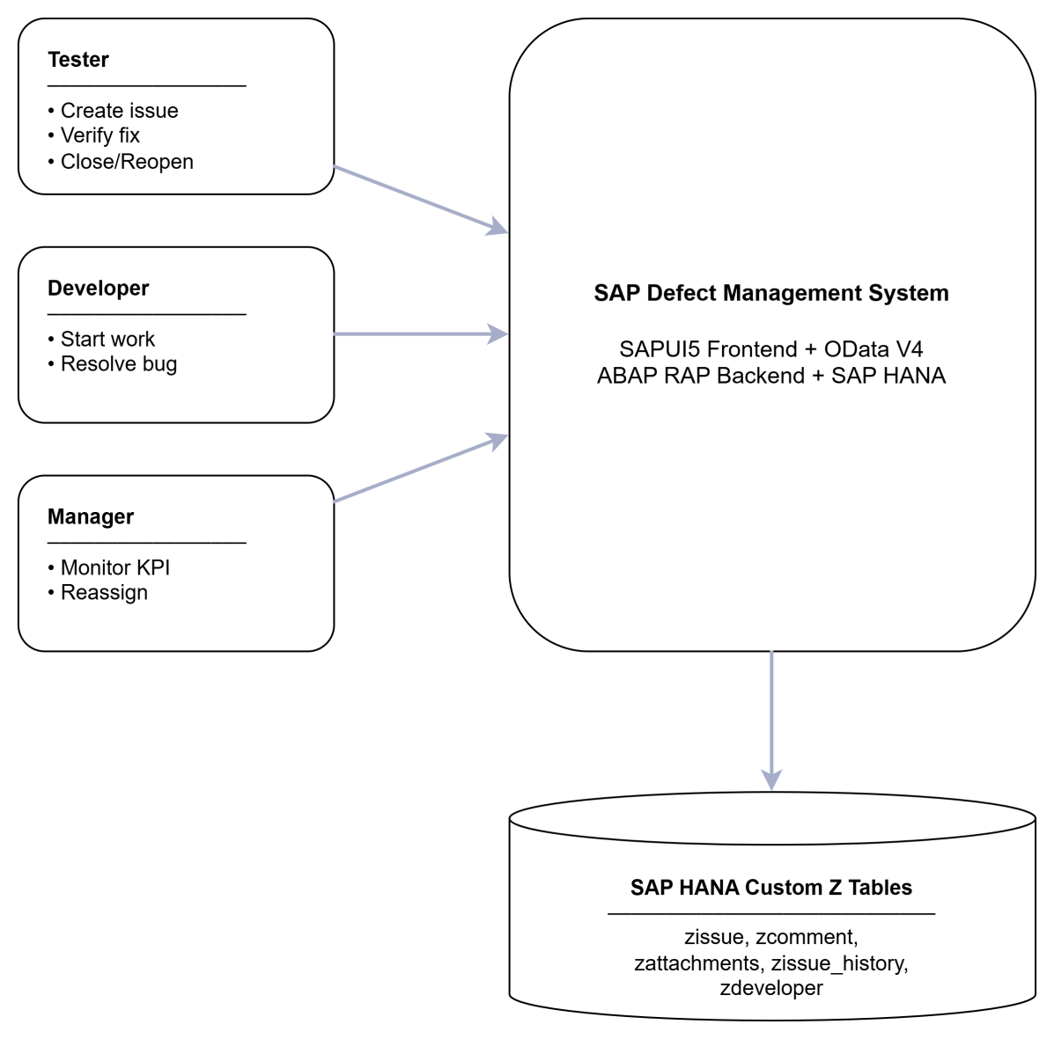

1.2 User Requirements
Actors

Actor | Description
Tester | User who creates defect tickets, verifies fixes, closes tickets, or reopens issues if the fix is not successful.
Developer | User who receives assigned tickets, analyzes defects, fixes issues, and resolves tickets with root cause and fix description.
Manager | User who monitors the defect management process, reviews KPI dashboards, and assigns or reassigns developers.
System | SAP Fiori application and ABAP RAP backend that manage data, validation, lifecycle transitions, and audit history.

Use Case List
Use Case ID | Use Case Name | Primary Actor | Description
UC-01 | Login to System | Tester / Developer / Manager | User logs in and receives role-based access.
UC-02 | View Issue List | Tester / Developer / Manager | User views ticket list with search, filter, and sorting.
UC-03 | Create Defect Ticket | Tester | Tester creates a new defect ticket with module, severity, description, due date, and attachment.
UC-04 | Assign Developer | Manager / System | Manager or system assigns a developer to a ticket.
UC-05 | Start Progress | Developer | Developer starts processing an assigned ticket.
UC-06 | Resolve Issue | Developer | Developer resolves the issue with root cause and fix description.
UC-07 | Start Testing | Tester | Tester starts verification after the developer resolves the issue.
UC-08 | Close Issue | Tester | Tester closes the ticket after successful verification.
UC-09 | Reopen Issue | Tester | Tester reopens the ticket if the fix is not successful.
UC-10 | Reassign Developer | Manager | Manager reassigns a reopened or assigned ticket to another developer.
UC-11 | Manage Comments | Tester / Developer / Manager | User views or adds comments for a ticket.
UC-12 | Manage Attachments | Tester / Developer / Manager | User views or uploads attachment information for a ticket.
UC-13 | View Audit History | Tester / Developer / Manager | User views ticket history and status changes.
UC-14 | View Dashboard | Manager | Manager views KPI dashboard and developer workload.

General Use Case Diagram Description
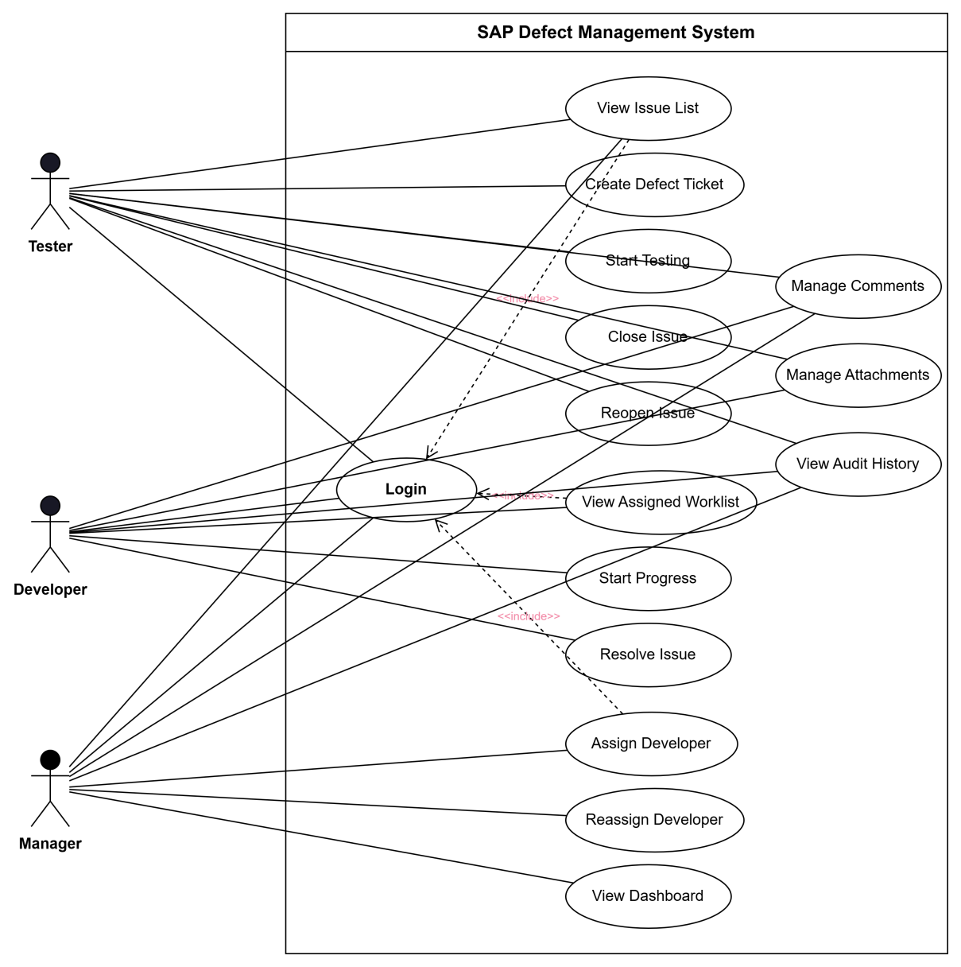

1.3 System Functionalities
The system provides the following major functions:

Function | Description
Login and Role Simulation | Allows users to log in as Tester, Developer, or Manager for demonstration purposes.
Issue List | Displays all defect tickets with search, module filtering, and sorting.
Create Issue | Allows Tester to create a new defect ticket with required business information.
Issue Detail | Displays full ticket information, attachments, comments, history, and workflow actions.
Developer Worklist | Displays tickets assigned to the current developer.
Tester Worklist | Displays tickets created by the tester and tickets waiting for verification.
Manager Dashboard | Displays KPI metrics such as open tickets, overdue tickets, critical tickets, SLA, MTTR, reopen rate, and workload.
Workflow Actions | Supports assignIssue, startProgress, resolveIssue, startTesting, closeIssue, and reopenIssue.
Audit History | Records major ticket changes and status transitions.
Comment Management | Allows users to record notes, root cause, and resolution-related comments.
Attachment Management | Stores attachment information such as file name, MIME type, and file size.

2. Functional Specifications
2.1 Defect Ticket Lifecycle Management
2.1.1 UC-03 Create Defect Ticket
Item | Description
Use Case ID | UC-03
Use Case Name | Create Defect Ticket
Primary Actor | Tester
Pre-condition | User is logged in as Tester.
Trigger | Tester clicks the “Create Issue” button.
Main Flow | 1. Tester opens Create Issue screen.<br>2. Tester enters title, description, module, severity, affected version, due date, and attachment information.<br>3. System validates required fields.<br>4. System selects or validates developer assignment.<br>5. Tester submits the form.<br>6. System creates a ticket and sets initial status as ASSIGNED.
Post-condition | A new ticket is created in zissue and displayed in Issue List.
Business Rules | Title, description, module, severity, and due date are required. Due date must not be in the past. Developer must be active and assigned to the selected module.

2.1.2 UC-05 Start Progress
Item | Description
Use Case ID | UC-05
Use Case Name | Start Progress
Primary Actor | Developer
Pre-condition | Ticket status is ASSIGNED and the ticket is assigned to the current developer.
Trigger | Developer clicks “Start Progress”.
Main Flow | 1. Developer opens assigned ticket.<br>2. Developer clicks Start Progress.<br>3. System calls RAP bound action startProgress.<br>4. Backend validates role and current status.<br>5. System updates status to IN_PROGRESS.
Post-condition | Ticket status becomes IN_PROGRESS.
Business Rules | Only Developer can start progress. Ticket must be assigned to the current developer.

2.1.3 UC-06 Resolve Issue
Item | Description
Use Case ID | UC-06
Use Case Name | Resolve Issue
Primary Actor | Developer
Pre-condition | Ticket status is IN_PROGRESS.
Trigger | Developer clicks “Resolve Issue”.
Main Flow | 1. Developer opens Resolve dialog.<br>2. Developer enters root cause and fix description.<br>3. System validates mandatory fields.<br>4. System calls RAP bound action resolveIssue.<br>5. Backend updates ticket status to RESOLVED.
Post-condition | Ticket status becomes RESOLVED and resolution information is saved.
Business Rules | Root cause and fix description are mandatory. Only Developer can resolve a ticket.

2.1.4 UC-07 Start Testing
Item | Description
Use Case ID | UC-07
Use Case Name | Start Testing
Primary Actor | Tester
Pre-condition | Ticket status is RESOLVED.
Trigger | Tester clicks “Start Testing”.
Main Flow | 1. Tester opens a resolved ticket.<br>2. Tester clicks Start Testing.<br>3. System calls RAP bound action startTesting.<br>4. Backend updates status to TESTING.
Post-condition | Ticket status becomes TESTING.
Business Rules | Only Tester can start testing. Ticket must be in RESOLVED status.

2.1.5 UC-08 Close Issue
Item | Description
Use Case ID | UC-08
Use Case Name | Close Issue
Primary Actor | Tester
Pre-condition | Ticket status is TESTING.
Trigger | Tester confirms that the fix is successful.
Main Flow | 1. Tester reviews the fixed issue.<br>2. Tester clicks Close Issue.<br>3. System calls RAP bound action closeIssue.<br>4. Backend updates status to CLOSED.
Post-condition | Ticket status becomes CLOSED.
Business Rules | Only Tester can close a ticket. Closed tickets are not considered overdue.

2.1.6 UC-09 Reopen Issue
Item | Description
Use Case ID | UC-09
Use Case Name | Reopen Issue
Primary Actor | Tester
Pre-condition | Ticket status is RESOLVED, TESTING, or CLOSED.
Trigger | Tester finds that the issue is not fully fixed.
Main Flow | 1. Tester opens Reopen dialog.<br>2. Tester enters reopen reason.<br>3. System validates input.<br>4. System calls RAP bound action reopenIssue.<br>5. Backend updates status to REOPEN and increases reopen count.
Post-condition | Ticket status becomes REOPEN.
Business Rules | Reopen reason is mandatory. Reopen count must be increased.

2.1.7 UC-10 Reassign Developer
Item | Description
Use Case ID | UC-10
Use Case Name | Reassign Developer
Primary Actor | Manager
Pre-condition | Ticket exists and requires assignment or reassignment.
Trigger | Manager clicks Assign/Reassign.
Main Flow | 1. Manager opens Reassign dialog.<br>2. Manager selects a developer.<br>3. System validates selected developer.<br>4. System calls RAP bound action assignIssue.<br>5. Backend updates assigned developer and ticket status.
Post-condition | Ticket is assigned to the selected developer.
Business Rules | Developer must be active and support the related SAP module.

3. UI Requirements
3.1 Login and Role Access
3.1.1 Login Screen
Screen name: Login
Brief description:
The Login screen allows users to access the application using a simulated account. The system identifies the role of the logged-in user and displays functions based on role permission.
Related use cases:
UC-01 Login to System
Prototype / Mockup:
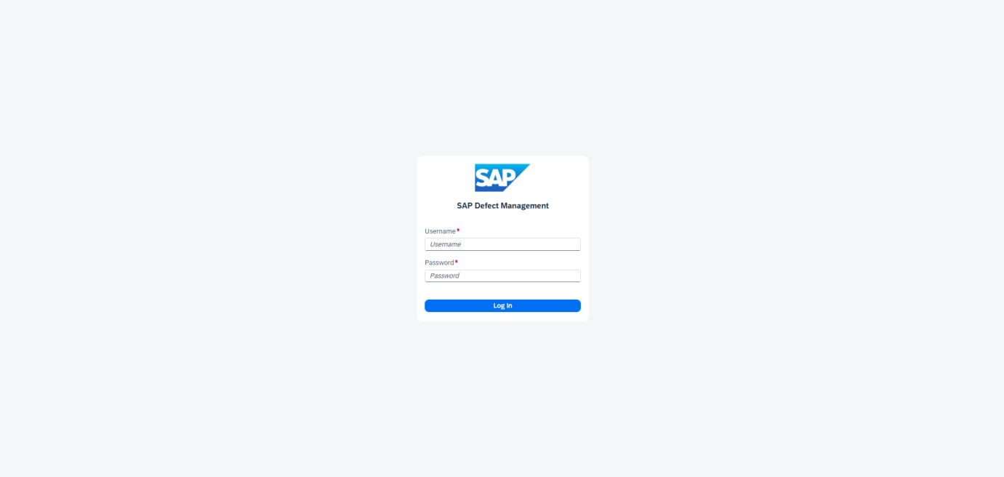
UI Requirements:
Field / Component | Requirement
Username | Required input field
Password | Required input field
Login Button | Triggers login validation
Error Message | Displayed if username or password is invalid
Session Storage | Stores logged-in user and role information

3.2 Issue List
3.2.1 Issue List Screen
Screen name: IssueList
Brief description:
The Issue List screen displays defect tickets from the OData Issue entity set. Users can search, filter, sort, and open ticket details.
Related use cases:
UC-02 View Issue List, UC-03 Create Defect Ticket, UC-14 View Dashboard
Prototype / Mockup:
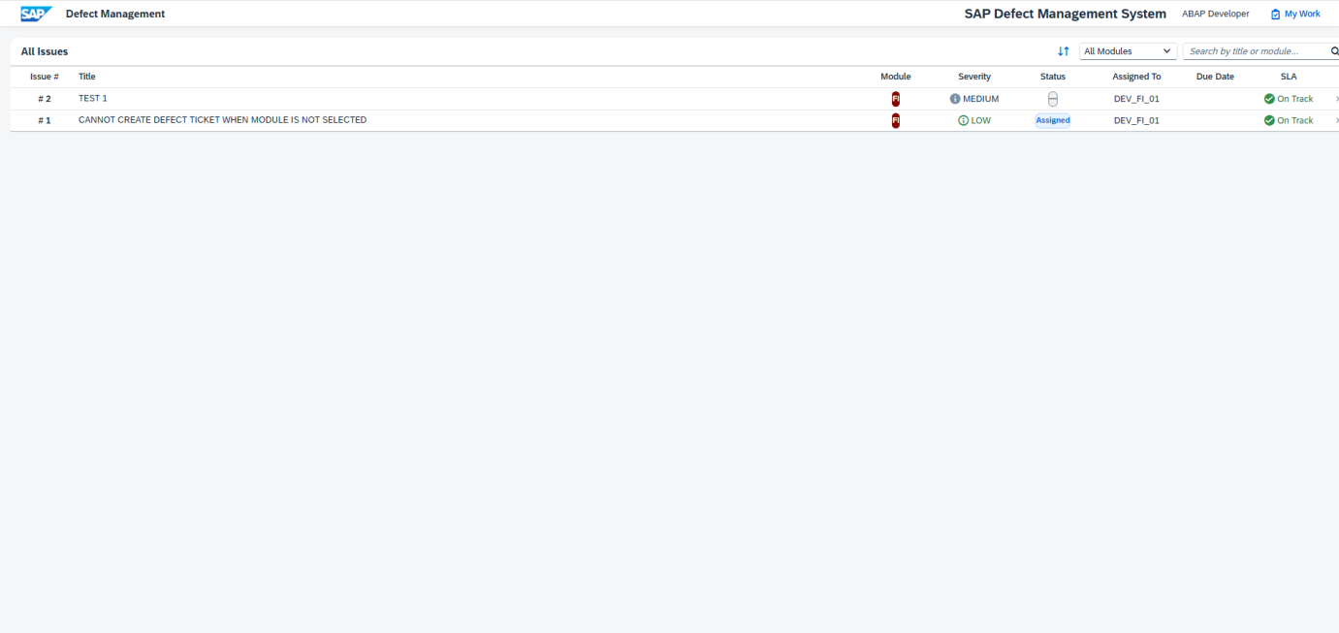
UI Requirements:

Component | Requirement
Search Field | Search ticket by title or module
Module Filter | Filter tickets by SAP module
Sort Action | Sort ticket list by status, severity, due date, or created date
Issue Table/List | Display issue number, title, module, severity, status, assignee
Create Button | Visible for Tester
Dashboard Button | Visible for Manager
Navigation | Clicking a ticket opens IssueDetail

3.3 Create Issue
3.3.1 Create Issue Screen
Screen name: CreateIssue
Brief description:
This screen allows Tester to create a new defect ticket. The form collects defect details and validates mandatory fields before submission.
Related use cases:
UC-03 Create Defect Ticket
Prototype / Mockup:
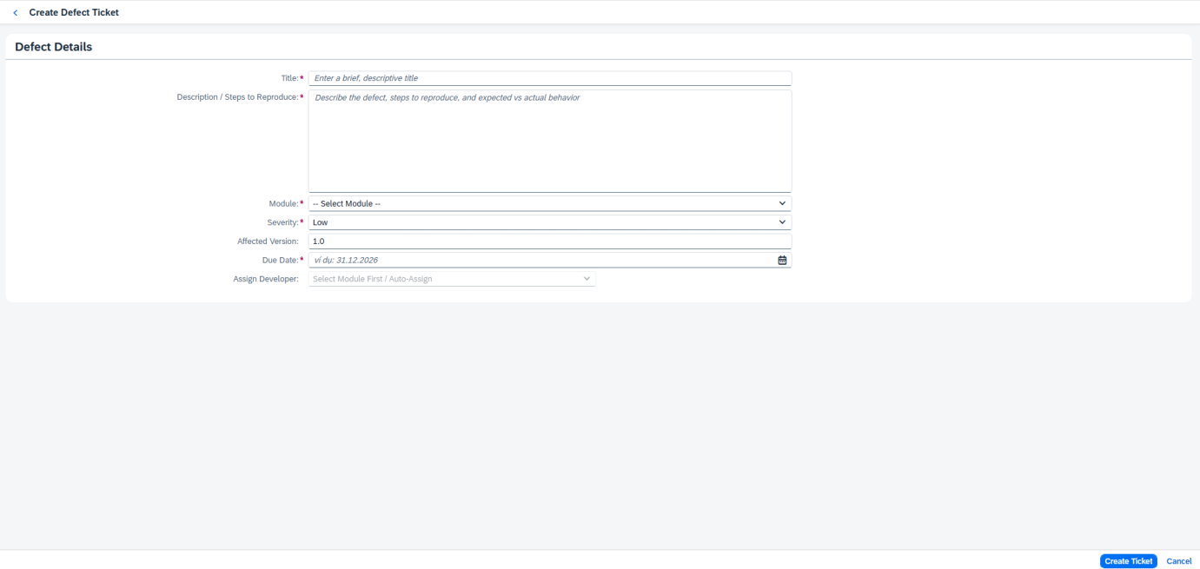
UI Requirements:

Field / Component | Requirement
Title | Required
Description | Required
Module | Required; values include FI, MM, SD, HCM, PP, QM
Severity | Required; LOW, MEDIUM, HIGH, CRITICAL
Due Date | Required; cannot be in the past
Developer | Must be active and support the selected module
Submit Button | Creates ticket through OData
Cancel Button | Returns to Issue List

3.4 Issue Detail
3.4.1 Issue Detail Screen
Screen name: IssueDetail
Brief description:
The Issue Detail screen is the central screen for viewing ticket details and performing lifecycle actions.
Related use cases:
UC-05 Start Progress, UC-06 Resolve Issue, UC-07 Start Testing, UC-08 Close Issue, UC-09 Reopen Issue, UC-10 Reassign Developer, UC-11 Manage Comments, UC-12 Manage Attachments, UC-13 View Audit History
Prototype / Mockup:
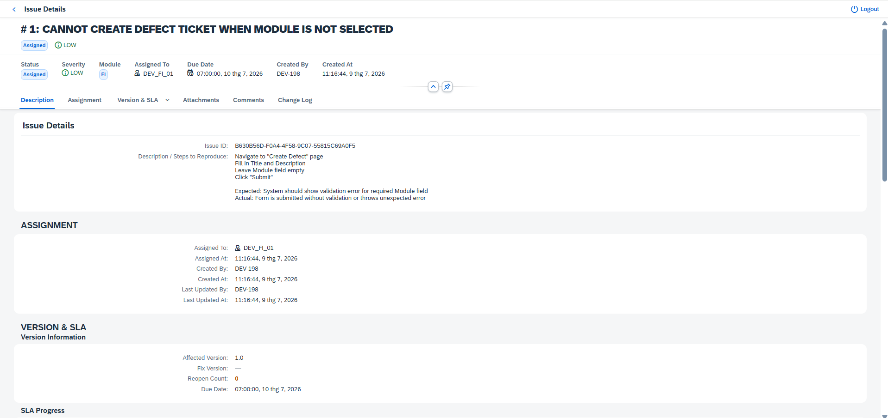
UI Requirements:

Component | Requirement
Header | Displays issue number, title, status, severity, and module
General Section | Shows title, description, module, version, due date
Assignment Section | Shows assigned developer and workload information
Resolution Section | Shows root cause, fix description, fix version
Attachment Section | Shows uploaded file metadata
Comment Section | Allows users to view/add comments
History Section | Displays audit trail
Action Buttons | Visible based on role and ticket status

3.5.1 Developer Worklist Screen
Screen name: DeveloperWorklist
Brief description:
This screen shows tickets assigned to the current developer and requiring action.
Related use cases:
UC-05 Start Progress, UC-06 Resolve Issue
Prototype / Mockup:

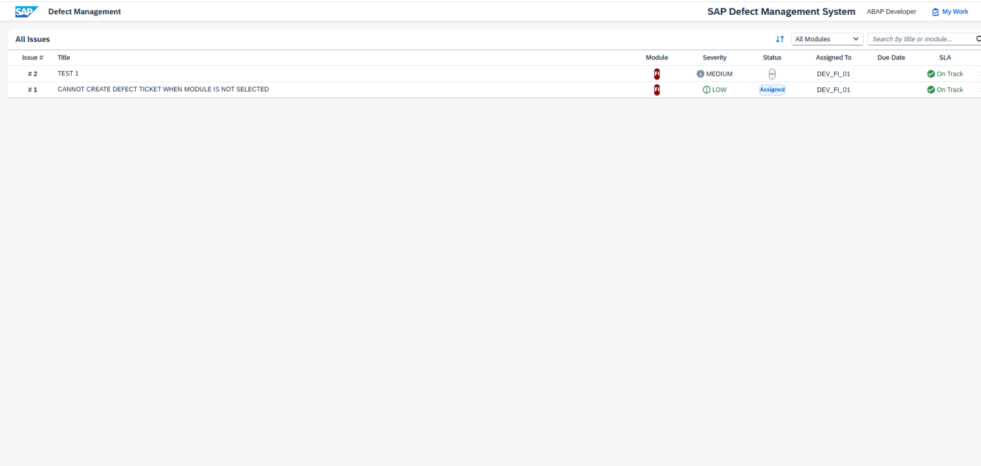
UI Requirements:
Component | Requirement
Worklist Table | Shows assigned tickets
Status Filter | Displays ASSIGNED, IN_PROGRESS, and REOPEN tickets
Ticket Navigation | Opens IssueDetail
Action Visibility | Start Progress and Resolve are available based on status

3.6 Tester Worklist
3.6.1 Tester Worklist Screen
Screen name: TesterWorklist
Brief description:
This screen allows Tester to track created tickets and tickets waiting for verification.
Related use cases:
UC-07 Start Testing, UC-08 Close Issue, UC-09 Reopen Issue
Prototype / Mockup:
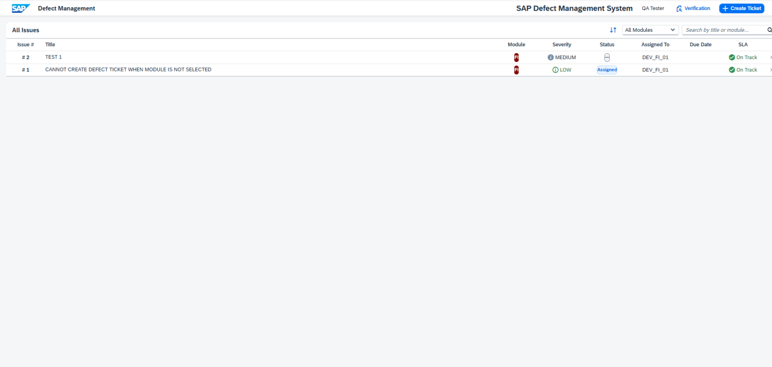
UI Requirements:

Component | Requirement
My Tickets List | Shows tickets created by the current tester
Verification List | Shows RESOLVED or TESTING tickets
Ticket Navigation | Opens IssueDetail
Action Visibility | Start Testing, Close, and Reopen are available based on status

3.7 Dashboard
3.7.1 Manager Dashboard Screen
Screen name: Dashboard
Brief description:
The Dashboard provides management-level monitoring of defect tickets, SLA status, reopen rate, MTTR, and developer workload.
Related use cases:
UC-14 View Dashboard
Prototype / Mockup:
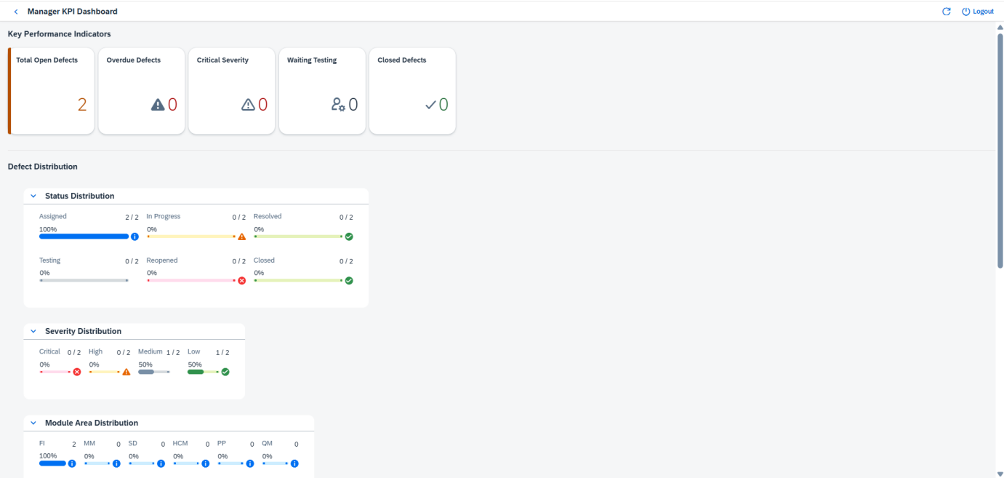
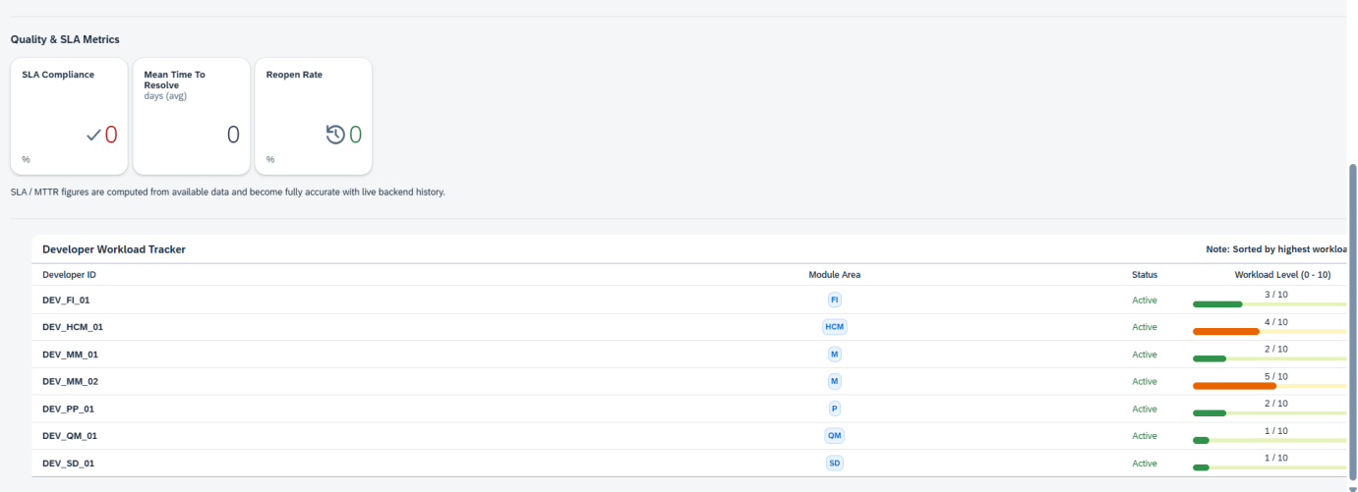
UI Requirements:

Component | Requirement
KPI Tiles | Show open, overdue, critical, SLA, MTTR, reopen rate
Charts | Show distribution by status, severity, and module
Workload Table | Shows developer workload
Manager Access | Dashboard is mainly visible for Manager
Data Source | Issue, History, and Developer entity sets

4. Non-Functional Requirements

4.1 External Interfaces
Interface | Description
SAPUI5 Frontend | User interface for all roles
OData V4 Service | Communication protocol between frontend and backend
ABAP RAP Backend | Provides business object, lifecycle actions, and validations
SAP HANA Database | Stores issue, comment, attachment, history, and developer data
Browser | End users access the Fiori application through a web browser
Mockserver | Used for local frontend development and demo fallback

External interface requirements
- The frontend must communicate with backend services using OData V4.
- The backend must expose Issue, Attachment, Comment, History, and Developer entity sets.
- The system must support standard browser access.
- The frontend must handle OData errors and display user-friendly messages.
- The application should be compatible with SAPUI5 1.120+.

4.2 Quality Attributes
Attribute | Requirement
Usability | UI must be simple, role-based, and consistent with SAP Fiori design principles.
Reliability | Lifecycle actions must update ticket status correctly and prevent invalid transitions.
Maintainability | Code should be separated by controller, view, formatter, service, and backend class.
Performance | Issue list and dashboard should load within an acceptable time for demo data volume.
Security | Role-based access should be enforced conceptually in UI and backend authorization design.
Auditability | Important ticket changes must be stored in history records.
Scalability | The design should allow server-side aggregation and real authentication in future versions.
Compatibility | The application should run on SAPUI5 1.120+ and support OData V4.
Testability | Business rules should be testable through unit, functional, scenario, and UAT cases.
Extensibility | New modules, statuses, notifications, or integrations can be added in future phases.

5. Requirement Appendix

5.1 Business Rules
Rule ID | Business Rule
BR-01 | A defect ticket must have title, description, module, severity, and due date.
BR-02 | Due date must not be earlier than the current date.
BR-03 | A developer must be active and assigned to the selected SAP module.
BR-04 | When a ticket is created, the initial status is ASSIGNED.
BR-05 | Only Developer can change ticket status from ASSIGNED to IN_PROGRESS.
BR-06 | Only Developer can resolve a ticket from IN_PROGRESS to RESOLVED.
BR-07 | Root cause and fix description are mandatory when resolving an issue.
BR-08 | Only Tester can move a ticket from RESOLVED to TESTING.
BR-09 | Only Tester can close a ticket from TESTING to CLOSED.
BR-10 | Tester can reopen a ticket if the fix is not successful.
BR-11 | Reopen reason is mandatory when reopening a ticket.
BR-12 | Reopen count must increase whenever a ticket is reopened.
BR-13 | Manager can assign or reassign developer for a ticket.
BR-14 | Closed tickets must not be shown as overdue.
BR-15 | Major status changes must be written to issue history.
BR-16 | Dashboard KPIs are calculated from Issue, History, and Developer data.

5.2 Common Requirements
Requirement ID | Requirement
CR-01 | The system must provide consistent navigation between list, detail, create, worklist, and dashboard screens.
CR-02 | The system must display user-friendly error messages for validation and OData errors.
CR-03 | The system must display buttons based on current role and ticket status.
CR-04 | The system must refresh ticket data after each workflow action.
CR-05 | The system must support search and filtering in issue list.
CR-06 | The system must display important ticket information clearly in IssueDetail.
CR-07 | The system must provide audit history for ticket status changes.
CR-08 | The system must allow future extension for real authentication and notification.

5.3 Application Messages List

Message ID | Message Text | Trigger
MSG-01 | Username and password are required. | Login fields are empty
MSG-02 | Invalid username or password. | Login validation fails
MSG-03 | Title is required. | Create Issue validation
MSG-04 | Description is required. | Create Issue validation
MSG-05 | Due date cannot be in the past. | Create Issue validation
MSG-06 | Developer is not valid for the selected module. | Developer validation
MSG-07 | Issue created successfully. | Ticket creation succeeds
MSG-08 | Failed to create issue. Please try again. | Ticket creation fails
MSG-09 | Issue status updated successfully. | Workflow action succeeds
MSG-10 | Failed to update issue status. | Workflow action fails
MSG-11 | Root cause is required. | Resolve Issue validation
MSG-12 | Fix description is required. | Resolve Issue validation
MSG-13 | Reopen reason is required. | Reopen Issue validation
MSG-14 | Attachment uploaded successfully. | Attachment upload succeeds
MSG-15 | Dashboard data loaded successfully. | Dashboard load succeeds
MSG-16 | No data found. | Empty list/filter result
MSG-17 | You do not have permission to perform this action. | Role authorization check fails

5.4 Other Requirements…
5.4.1 Assumptions
No. | Assumption
1 | Users have access to the SAP Fiori application through a supported browser.
2 | Backend OData V4 service is available during integration testing.
3 | Developer master data is maintained before ticket assignment.
4 | SAP modules are predefined as FI, MM, SD, HCM, PP, and QM.
5 | The login function is simulated for academic/demo purposes.
5.4.2 Constraints
No. | Constraint
1 | The project focuses on one main creation channel: SAP Fiori UI.
2 | Email-to-ticket, AI suggestion, Jira integration, and SLA background job are out of scope.
3 | Dashboard aggregation is currently performed on the client side for demo data volume.
4 | Attachment handling currently focuses on metadata and requires enhancement for production binary handling.
5 | Real production authentication is not included in the current scope.
5.4.3 Main Data Entities
Entity | Description
Issue | Main defect ticket entity
Developer | Developer assignment and workload information
Attachment | Attachment metadata and file information
Comment | Ticket comments and notes
History | Audit history of ticket changes

5.4.4 Status Lifecycle

ASSIGNED
↓
IN_PROGRESS
↓
RESOLVED
↓
TESTING
↓
CLOSED

Alternative flow:
RESOLVED / TESTING / CLOSED
↓
REOPEN
↓
ASSIGNED
5.4.5 Role Authorization Summary
Function | Tester | Developer | Manager
Login | Yes | Yes | Yes
View Issue List | Yes | Yes | Yes
Create Issue | Yes | No | Optional / View only
Start Progress | No | Yes | No
Resolve Issue | No | Yes | No
Start Testing | Yes | No | No
Close Issue | Yes | No | No
Reopen Issue | Yes | No | No
Assign/Reassign Developer | No | No | Yes
View Dashboard | No | No | Yes
View History | Yes | Yes | Yes
Add Comment | Yes | Yes | Yes

IV. Software Design Description

1. System Design

1.1 System Architecture
The SAP Defect Management System is designed as a three-layer architecture:
1.Presentation Layer (Frontend)
SAPUI5 1.120+ with TypeScript, XML Views, and MVC controllers.
2.Service Layer (API)
OData V4 service exposed by ABAP RAP.
3.Business / Persistence Layer (Backend)
ABAP RAP business object, CDS View Entities, ABAP OO business logic, and SAP HANA custom Z tables
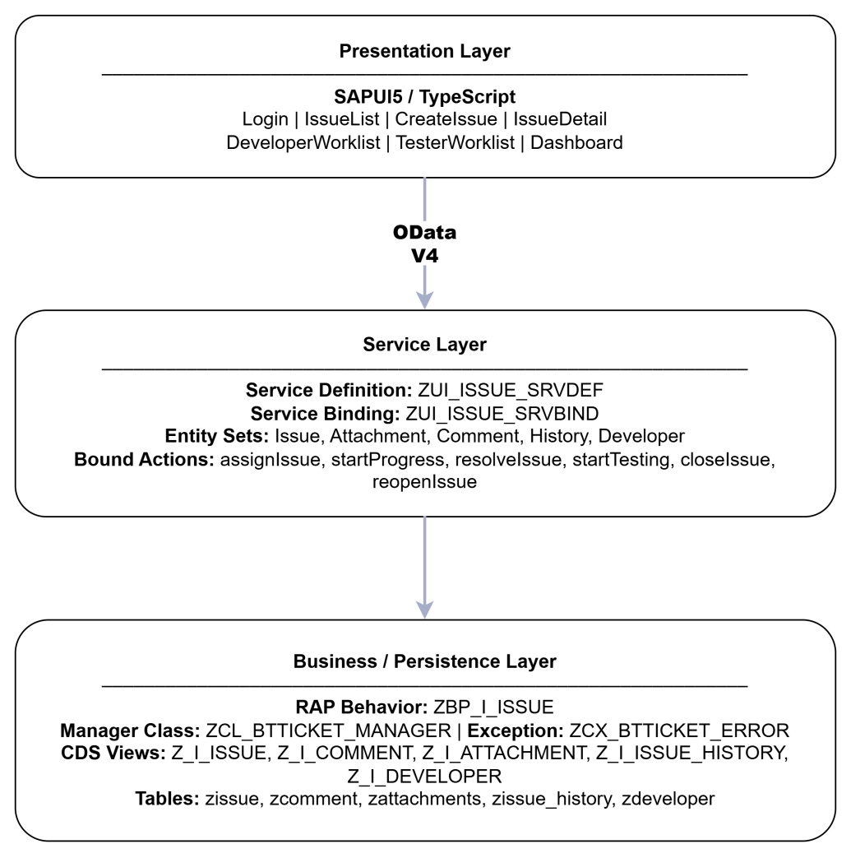

Architecture principles
Principle | Description
Separation of concerns | UI, service contract, and business logic are separated
Role-based design | Tester, Developer, and Manager have different functions
Controlled lifecycle | Status transitions are executed by RAP bound actions
Auditability | Important changes are written into history records
Extensibility | Future authentication, notification, and aggregation can be added

1.2 Package Diagram
Frontend package structure
sap.defectmgmt
├── controller
│ ├── App.controller.ts
│ ├── BaseController.ts
│ ├── Login.controller.ts
│ ├── IssueList.controller.ts
│ ├── CreateIssue.controller.ts
│ ├── IssueDetail.controller.ts
│ ├── DeveloperWorklist.controller.ts
│ ├── TesterWorklist.controller.ts
│ └── Dashboard.controller.ts
├── view
│ ├── Login.view.xml
│ ├── IssueList.view.xml
│ ├── CreateIssue.view.xml
│ ├── IssueDetail.view.xml
│ ├── DeveloperWorklist.view.xml
│ ├── TesterWorklist.view.xml
│ └── Dashboard.view.xml
├── model
│ ├── models.ts
│ └── formatter.ts
├── i18n
├── localService / mockdata
└── manifest.json

Backend package structure
Z_BTTICKET / Custom Z Namespace
├── Dictionary Objects
│ ├── Tables: zissue, zcomment, zattachments, zissue_history, zdeveloper
│ ├── Domains: ZISSUE_MODULE, ZISSUE_SEVERITY, ZISSUE_STATUS, ZCOMMENT_TYPE
│ └── Data Elements: ZDE_ISSUE_ID, ZDE_ISSUE_NUM, ...
├── CDS View Entities
│ ├── Z_I_ISSUE
│ ├── Z_I_COMMENT
│ ├── Z_I_ATTACHMENT
│ ├── Z_I_ISSUE_HISTORY
│ └── Z_I_DEVELOPER
├── RAP Objects
│ ├── Behavior Definition: Z_I_ISSUE
│ ├── Behavior Pool: ZBP_I_ISSUE
│ ├── Service Definition: ZUI_ISSUE_SRVDEF
│ └── Service Binding: ZUI_ISSUE_SRVBIND
└── ABAP Classes
├── ZCL_BTTICKET_MANAGER
├── ZCX_BTTICKET_ERROR
└── ZCL_BTTICKET_MANAGER_TEST

2. Database Design
The database design contains five custom transparent tables: zissue, zcomment, zattachments, zissue_history and zdeveloper. Exposed OData Entity Sets are Issue, Attachment, Comment, History and Developer.
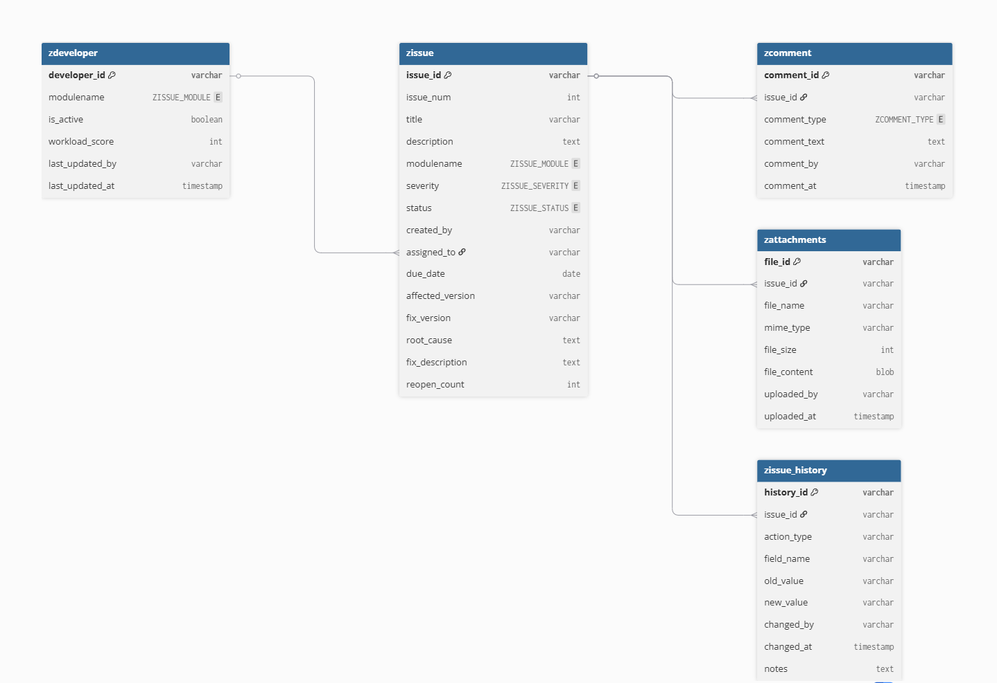

3. Detailed Design

3.1 <Feature/Function Name1>

3.1.1 Class Diagram
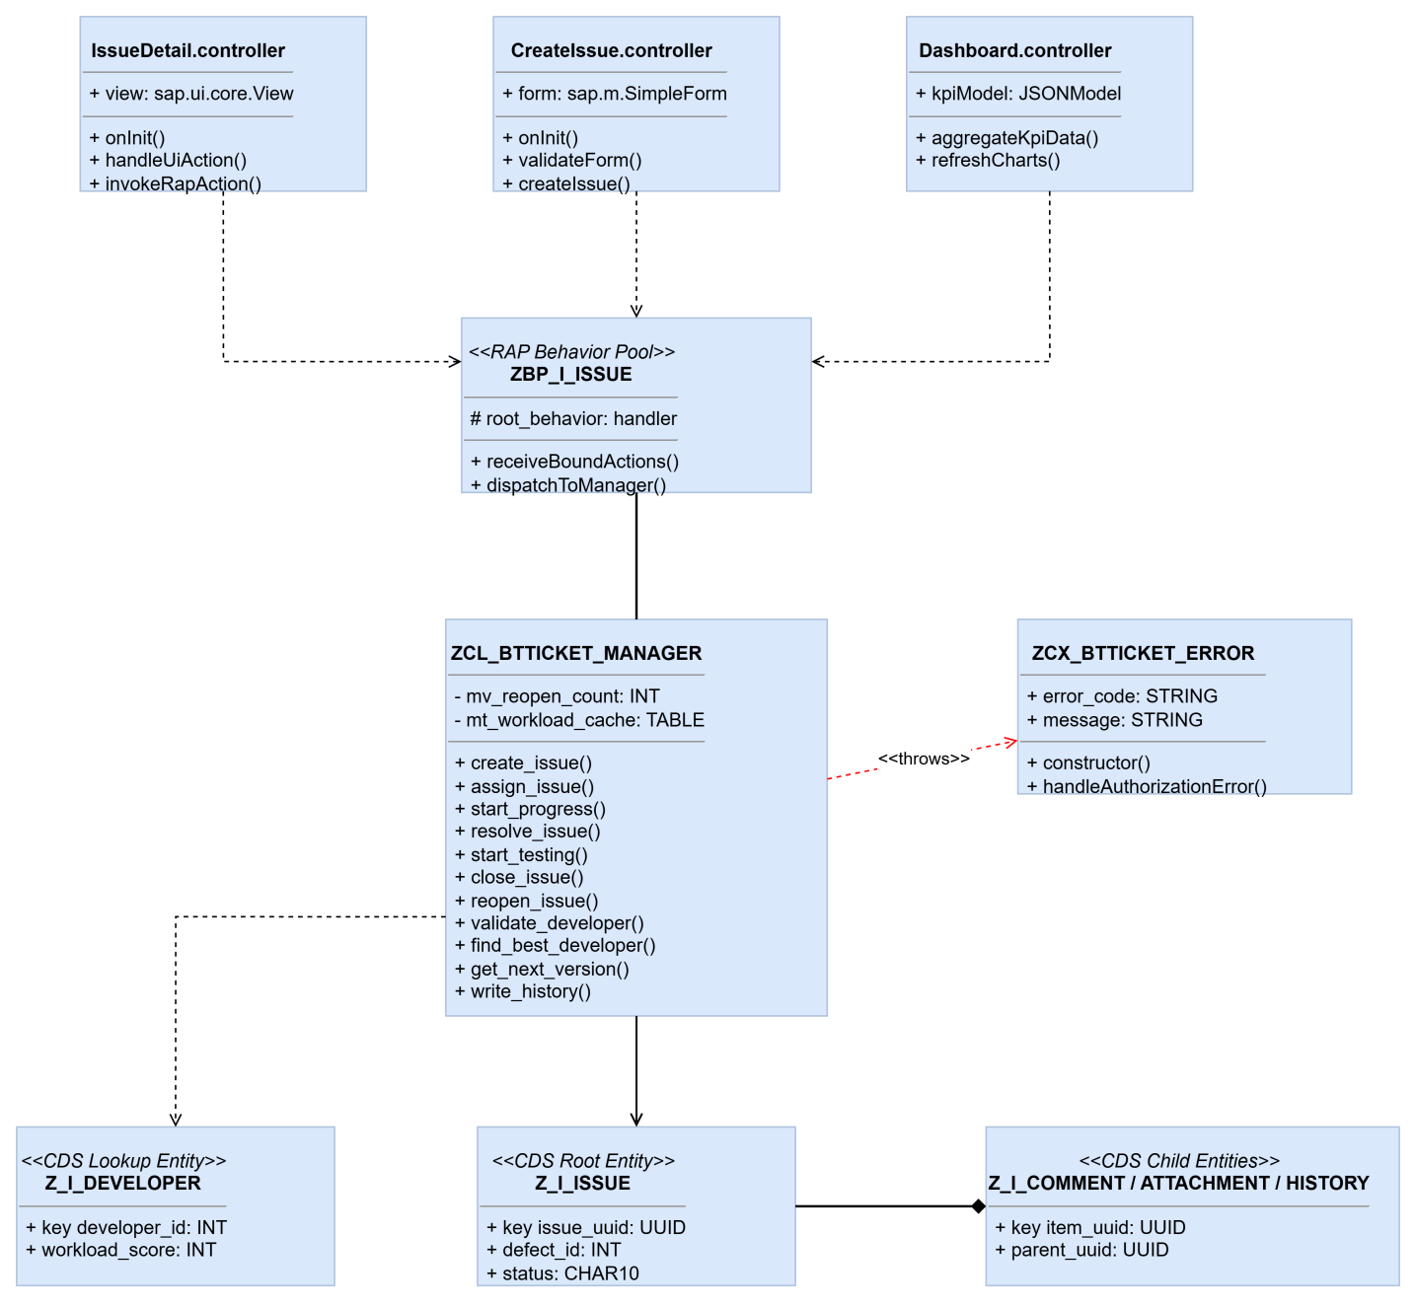

3.1.2 Sequence Diagram – Create Issue
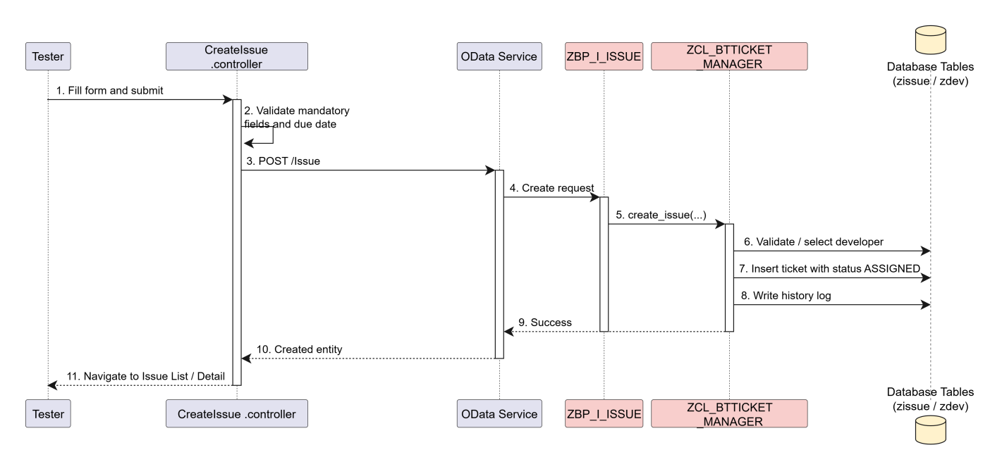

3.1.3 Sequence Diagram – Resolve Issue
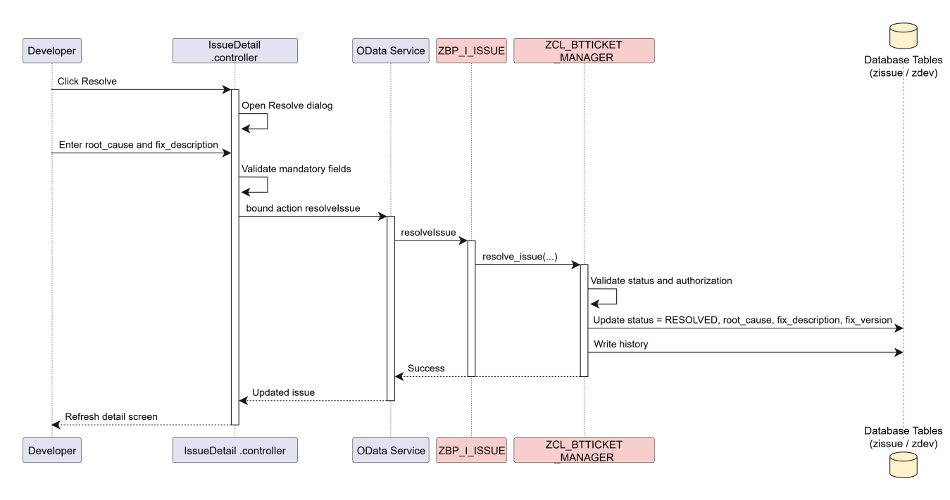

3.1.4 Sequence Diagram – Reopen and Reassign

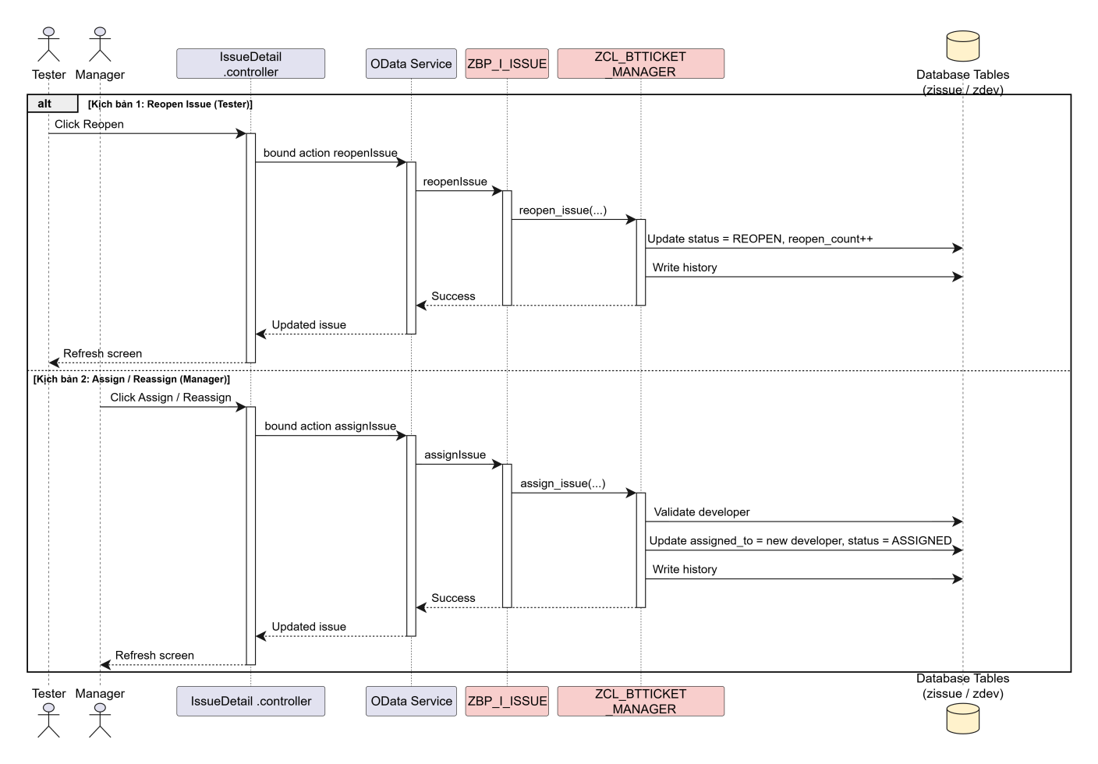

3.2 Frontend Detailed Design

Screen | Controller | Main Functions
Login | Login.controller.ts | Validate credentials, map role, store session
IssueList | IssueList.controller.ts | Search, filter, sort, navigate
CreateIssue | CreateIssue.controller.ts | Validate form, create ticket, auto-select developer
IssueDetail | IssueDetail.controller.ts | Display detail, invoke actions, manage comments/attachments/history
Developer Worklist | DeveloperWorklist.controller.ts | Filter assigned tickets
TesterWorklist | TesterWorklist.controller.ts | Show created tickets and verification queue
Dashboard | Dashboard.controller.ts | Aggregate KPI and workload data

3.3 OData Design
Entity Set | Source | Methods | Purpose
Issue | Z_I_ISSUE | GET, POST, PATCH, DELETE | Main ticket entity
Attachment | Z_I_ATTACHMENT | GET, PATCH, DELETE | Attachment data
Comment | Z_I_COMMENT | GET, PATCH, DELETE | Comments
History | Z_I_ISSUE_HISTORY | GET | Audit history
Developer | Z_I_DEVELOPER | GET | Developer lookup

Bound Actions
Action | Transition | Role
assignIssue | REOPEN / ASSIGNED → ASSIGNED | Manager
startProgress | ASSIGNED → IN_PROGRESS | Developer
resolveIssue | IN_PROGRESS → RESOLVED | Developer
startTesting | RESOLVED → TESTING | Tester
closeIssue | TESTING → CLOSED | Tester
reopenIssue | RESOLVED / TESTING / CLOSED → REOPEN | Tester

V. Software Testing Documentation

1. Scope of Testing
1.1 In-scope features
Area | Description
Login | Role-based simulated login
Issue List | Search, filter, sort, navigation
Create Issue | Mandatory validation, past due date validation, developer selection
Issue Detail | Lifecycle actions, comments, attachments, history
Developer Worklist | Assigned ticket filtering
Tester Worklist | Created tickets and verification tickets
Dashboard | KPI aggregation and workload view
Backend lifecycle logic | Status transitions and validation rules
Authorization concept | Role matrix for Tester / Developer / Manager
1.2 Testing levels
Level | Purpose
Unit Test | Validate controller methods, form validation, formatter logic, and backend manager methods
Functional Test | Validate each screen and feature independently
Integration / Scenario Test | Validate end-to-end defect lifecycle and reassignment flow
UAT | Validate business acceptance from end-user perspective

1.3 Assumptions and constraints
Item | Description
Assumption | Mock data or demo service is available for frontend testing
Assumption | Backend actions follow the designed lifecycle transitions
Constraint | Production authentication is not fully tested because login is simulated
Constraint | Attachment binary handling is limited to metadata in current scope
Constraint | Dashboard is tested with demo data volume, not large production volume

2. Test Strategy

2.1 Testing Types
Testing Type | Description | Applied To
Functional Testing | Verify each function works according to requirements | All screens and actions
Validation Testing | Verify mandatory fields and business rules | Create Issue, Resolve, Reopen, Login
Role-based Testing | Verify button visibility and action permission by role | Login, IssueDetail, Worklists, Dashboard
Integration Testing | Verify frontend–backend OData and RAP actions | Create, Start Progress, Resolve, Close, Reopen, Assign
UI Testing | Verify screen layout, navigation, and user flow | All screens
Regression Testing | Re-test main lifecycle after changes | Core defect lifecycle
UAT | Confirm business acceptance | End-to-end scenarios

2.2 Test Levels
Level | Focus | Owner
Unit | Method-level logic | Developers
Functional | Feature-level behavior | Developers + Documentation
Scenario / Integration | Multi-step business flow | Whole team

2.3 Supporting Tools
Tool | Purpose
Visual Studio Code | Frontend development and debugging
Chrome DevTools | UI and network debugging
Browser | OData service verification
SAP ADT | Backend debugging and unit testing
Mockserver / Mock JSON | Local frontend testing without live backend

3. Test Plan

3.1 Human Resources
Role | Member | Responsibility
Backend Tester / Developer | Nguyễn Tiến Dũng – SE184951 | Backend unit tests, RAP action validation
Frontend Tester / Developer | Bùi Quang Tuấn – SE184982 | Frontend functional tests, integration tests, worklist/dashboard checks
Frontend Tester / Developer | Phạm Thị Minh Ánh – SE181595 | UI verification, support functional testing, main UI flows
Documentation / Test Case Owner | Project Team | Prepare Unit Test, Functional Test, Scenario, UAT documents

3.2 Test Environment
Item | Description
Frontend | SAPUI5 1.120+, TypeScript, local UI5 server
Backend | ABAP RAP, CDS, OData V4 service
Database | SAP HANA custom Z tables
Browser | Chrome
Demo mode | Mockserver with Issue, Developer, Comment, Attachment, History JSON
Integration mode | Live SAP OData endpoint if available

3.3 Test Milestones
Milestone | Description | Target Result
M1 | Unit test preparation completed | Controller/formatter and backend method cases ready
M2 | Functional test completed | Main screens validated
M3 | Integration scenario completed | Full lifecycle and reopen flow validated
M4 | UAT completed | Business scenarios accepted
M5 | Final demo ready | Stable demo path prepared

4. Test Cases
The detailed test cases are maintained in the following deliverables:
Document | Content
Unit_Test.xlsx | 14 unit test cases for validation, SLA, formatter, and login logic
Functional_Test.xlsx | 18 functional test cases for Login, IssueList, CreateIssue, IssueDetail, Dashboard
Test_Scenario.xlsx | 5 integrated scenarios for lifecycle, reopen, authorization, assignment, dashboard
UAT.xlsx | 6 user acceptance scenarios
Summary of prepared test coverage
Type | Count | Main Coverage
Unit Test | 14 | Form validation, past due date, SLA color, reopen state, login validation, resolve mandatory fields
Functional Test | 18 | Role login, search/filter/sort, create ticket, resolve dialog, attachment, dashboard
Test Scenario | 5 | End-to-end lifecycle, reopen + reassignment, auth negative, assignment validation, dashboard monitoring
UAT | 6 | Create, fix, verify/close, reopen, reassign, dashboard review

5. Test Reports
5.1 Expected test result summary
Area | Expected Result | Status
Login with valid roles | User can enter the system with correct role | Prepared
Create Issue validation | Missing mandatory fields and past due date are rejected | Prepared
Create Issue success | Ticket is created with ASSIGNED status | Prepared
Start Progress | Status changes from ASSIGNED to IN_PROGRESS | Prepared
Resolve Issue | Status changes to RESOLVED with root cause and fix description | Prepared
Start Testing / Close | Status changes to TESTING then CLOSED | Prepared
Reopen Issue | Status changes to REOPEN and reopen_count increases | Prepared
Reassign Developer | Manager can reassign ticket successfully | Prepared
Dashboard | KPI and workload information is displayed | Prepared

5.2 Defect categories during testing
Category | Example | Handling
Validation defect | Missing field accepted incorrectly | Fix validation rule
Authorization defect | Wrong role can see restricted button | Fix role matrix / UI condition
Integration defect | RAP action fails or wrong payload | Fix OData call / backend action
UI defect | Incorrect button visibility or layout | Fix controller/view
Data defect | Wrong status or missing history | Fix manager class / history write

5.3 Test conclusion
The testing package covers unit, functional, integrated scenario, and UAT levels. The main business flow of the SAP Defect Management System is verified through role-based scenarios and lifecycle transitions. Remaining known limitations, such as simulated login and client-side dashboard aggregation, are documented for future enhancement.

VI. Release Package & User Guides

1. Deliverable Package
No. | Deliverable | Location / Type
1 | Frontend source code | SAP-FRONTEND
2 | Backend source code | ĐỒ ÁN/Code
3 | Functional Specification | Excel
4 | Technical Specification | Excel
5 | Configuration Note | Excel
6 | Unit Test | Excel
7 | Functional Test | Excel
8 | Test Scenario | Excel
9 | UAT | Excel
10 | Blueprint | Word
11 | Final Project Report | Word
12 | Demo guide / presentation | Optional

2. Installation Guides

2.1 System Requirements
Component | Requirement
Browser | Chrome latest version
Frontend tools | Node.js, npm, UI5 tooling, VS Code
Backend tools | Eclipse ADT, SAP system access
SAP runtime | ABAP environment with RAP support
Database | SAP HANA
Network | Access to SAP OData endpoint or local mockserver

2.2 Installation Instruction
Frontend setup
- Open the SAP-FRONTEND project in VS Code.
- Install dependencies if required.
- Configure manifest.json service URI for live OData or mockserver.
- Start the local UI5 application.
- Open the application in browser.
Backend setup
- Import or activate dictionary objects:
zissue, zcomment, zattachments, zissue_history, zdeveloper
- Activate CDS views:
Z_I_ISSUE, Z_I_COMMENT, Z_I_ATTACHMENT, Z_I_ISSUE_HISTORY, Z_I_DEVELOPER
- Activate RAP behavior definition and behavior pool ZBP_I_ISSUE
- Activate service definition ZUI_ISSUE_SRVDEF
- Publish service binding ZUI_ISSUE_SRVBIND
- Maintain developer master data in zdeveloper
- Maintain authorization concept with Z_BTTICKET_ACT if required

3. User Manual

3.1 Overview
The SAP Defect Management System helps users manage SAP defects end to end:
- Tester creates and verifies tickets
- Developer processes and resolves tickets
- Manager monitors KPIs and reassigns developers
Main screens:
- Login
- Issue List
- Create Issue
- Issue Detail
- Developer Worklist
- Tester Worklist
- Dashboard

3.2 Workflow 1 – Standard Defect Lifecycle
Purpose
Create, process, verify, and close a defect ticket.
Workflow steps
Step | Actor | Action | Expected Result
1 | Tester | Login with as tester | Enter Issue List
2 | Tester | Click Create Issue | Open create form
3 | Tester | Enter title, description, module, severity, due date | Form is filled
4 | Tester | Submit ticket | Ticket is created with status ASSIGNED
5 | Developer | Login with as developer | Enter system
6 | Developer | Open My Work / Issue Detail | See assigned ticket
7 | Developer | Click Start Progress | Status becomes IN_PROGRESS
8 | Developer | Click Resolve and enter root cause + fix description | Status becomes RESOLVED
9 | Tester | Open ticket and click Start Testing | Status becomes TESTING
10 | Tester | Confirm fix and click Close | Status becomes CLOSED

3.3 Workflow 2 – Reopen and Reassignment

Purpose
Handle a failed fix and reassign the ticket.
Workflow steps
Step | Actor | Action | Expected Result
1 | Tester | Open a ticket in TESTING or RESOLVED | Ticket detail is displayed
2 | Tester | Click Reopen and enter reason | Status becomes REOPEN
3 | Manager | Login with as manager | Enter system
4 | Manager | Open reopened ticket | Ticket detail is displayed
5 | Manager | Click Assign / Reassign and choose another developer | Ticket is reassigned
6 | System | Update ticket | Status becomes ASSIGNED with new developer
7 | Manager | Open Dashboard | KPI and workload are updated

3.4 Screen-by-screen user guide
Login
- Enter username and password
- Click Login
- System stores role and navigates to Issue List
Issue List
- Search ticket by title or module
- Filter by module
- Sort list if needed
- Open a ticket to view details
- Use Create Issue or Dashboard depending on role

Create Issue
- Fill required fields
- Select module and severity
- Select due date
- Optionally select developer or let system choose lowest workload
- Submit the form

Issue Detail
- Review general information
- Review assignment, resolution, attachments, comments, history
- Perform allowed action based on role and status

Dashboard
- Login as Manager
- Open Dashboard
- Review open/overdue/critical tickets
- Review SLA, MTTR, reopen rate, and developer workload

VII. Project Results, Limitations and Future Development

1. Key Results Achieved
- Completed SAPUI5 TypeScript frontend with Login, IssueList, CreateIssue, IssueDetail, Dashboard, DeveloperWorklist, and TesterWorklist.
- Connected frontend to ABAP RAP OData V4 service.
- Implemented lifecycle bound actions: assignIssue, startProgress, resolveIssue, startTesting, closeIssue, reopenIssue.
- Designed and implemented data model with five custom tables.
- Implemented role-based process for Tester, Developer, and Manager.
- Prepared full project deliverables including specifications, configuration note, test documents, blueprint, and final report.

2. Limitations
- Login is simulated with hardcoded demo users.
- Dashboard currently aggregates data on the client side.
- Attachment handling mainly stores metadata.
- UI Flexibility is not enabled (flexEnabled = false).
- Frontend automated tests are not fully implemented.
- Some OData write constraints still require graceful fallback handling.

3. Future Development
- Replace simulated login with real SAP authentication.
- Implement server-side KPI aggregation.
- Complete full attachment upload/download.
- Enable SAPUI5 Flex personalization.
- Add QUnit/OPA5 automated frontend tests.
- Add notification and SLA escalation in later phases.

4. Conclusion
The project successfully demonstrates a practical SAP Fiori and RAP-based defect management solution. It supports end-to-end ticket lifecycle management, role-based user experience, auditability, and management reporting. Although some production-level features remain for future improvement, the current system fulfills the academic and technical objectives of the project.

